Reverse a String: Write a Python program that takes a string as input and prints the reverse of that string.

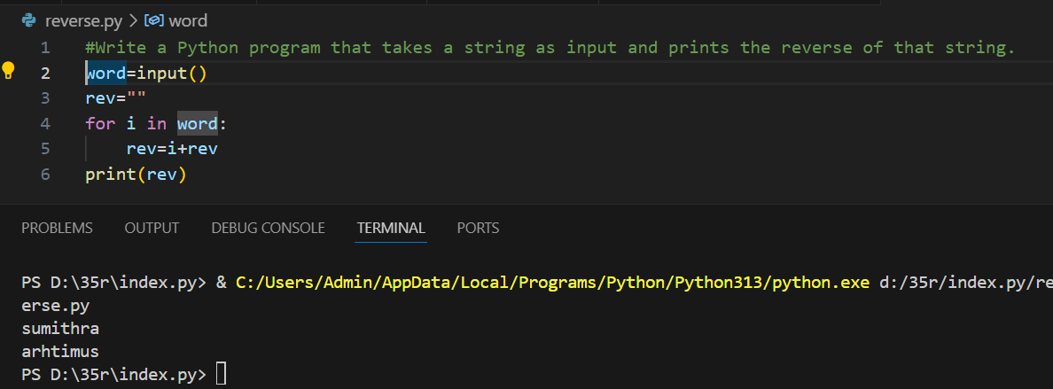

Count Vowels in a String: Write a program that counts the number of vowels (a, e, i, o, u) in a given string.

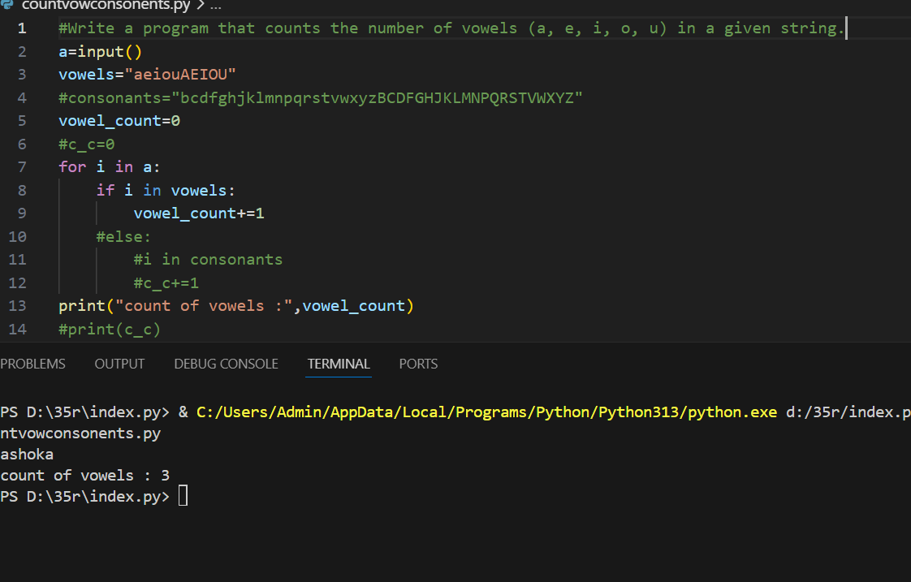

Check if a String is a Palindrome: Write a Python program to check if a given string is a palindrome.

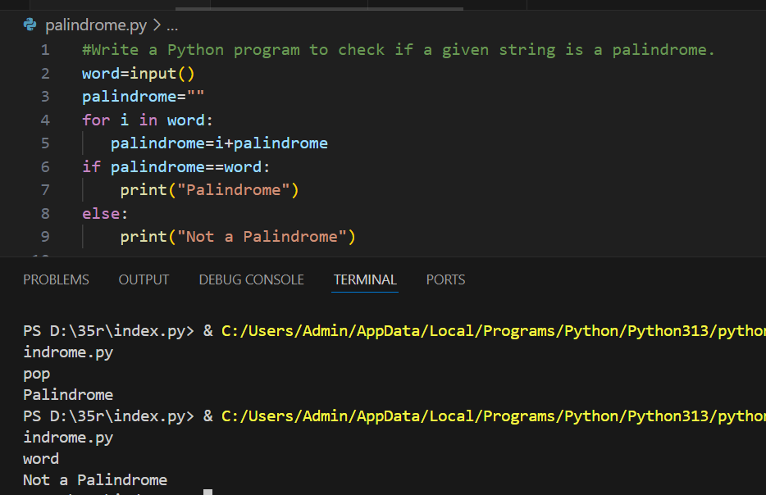

Count Occurrences of a Character: Write a Python program that counts how many times a specific character appears in a string.

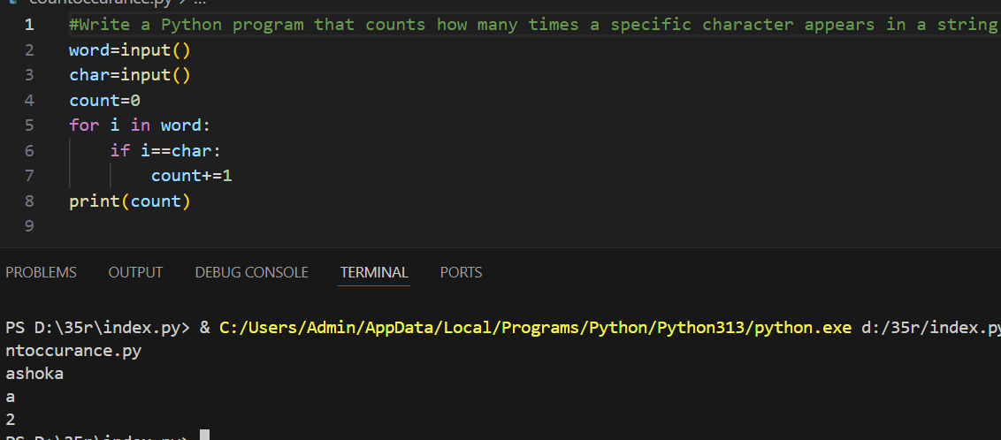

Remove Whitespace from a String: Write a Python program that removes all whitespaces from a given string.

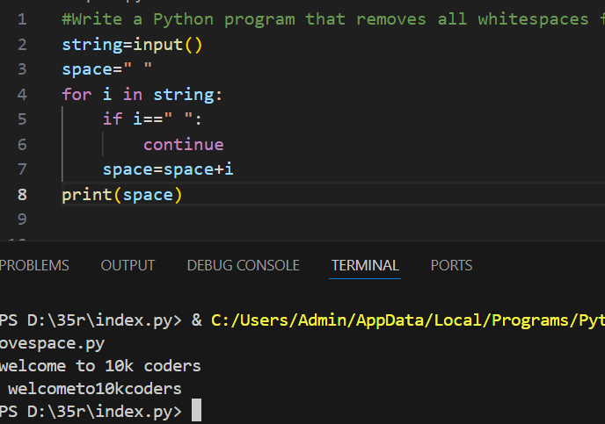

Find the Longest Word in a String: Write a Python program that finds the longest word in a string (assume the string is a sentence with words separated by spaces).

Replace All Spaces with Underscores: Write a program that replaces all spaces in a string with underscores (_).

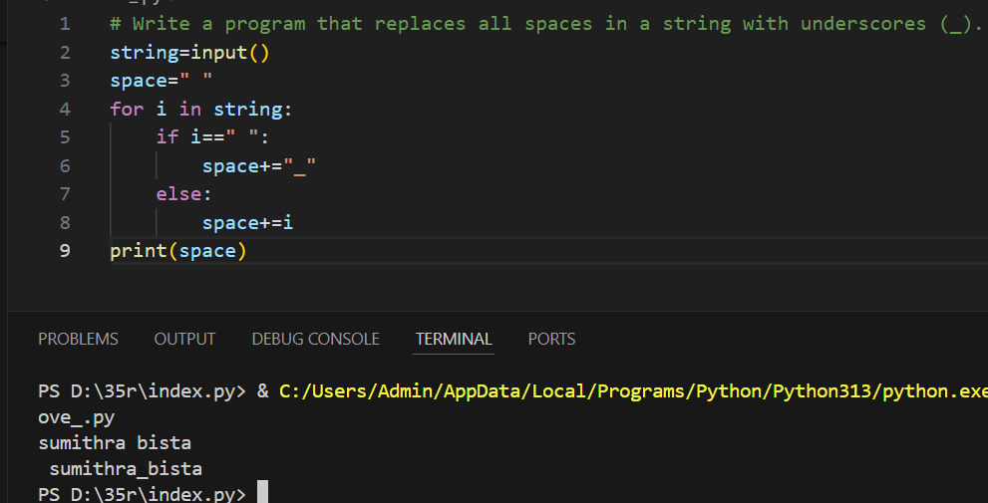

Check if a String Contains Only Digits: Write a Python program to check if a given string contains only digits.

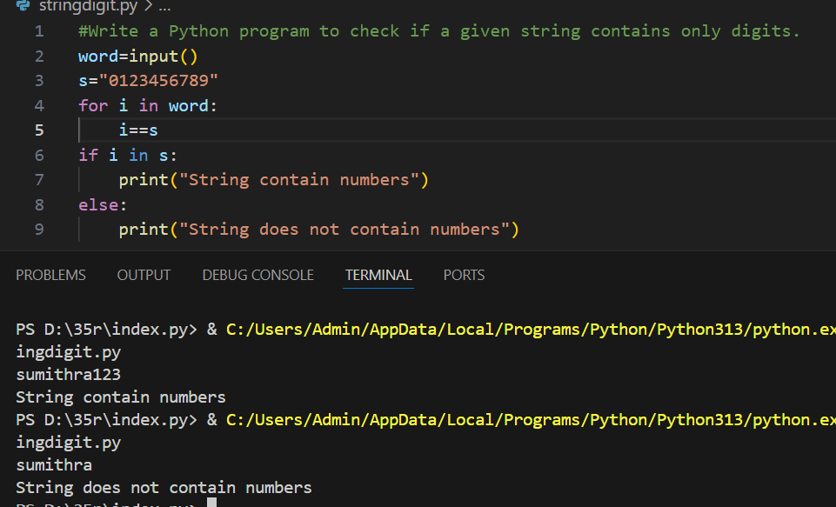

Extract a Substring Using Indexing: Write a Python program that extracts a substring from a given string using string slicing. The program should take two indices as input (start and end) and return the substring.

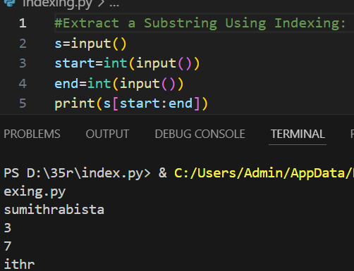

Iterate Over Each Character and Print Its ASCII Value: Write a program that iterates over each character in a string and prints its corresponding ASCII value.

